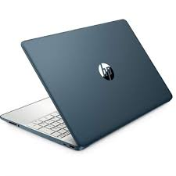

HP 15-EF2126

* AMD Ryzen 5 5500U
* 8 GB DDR4-3200 MHz
* AMD Radeon™ Graphics
* 15.6" FHD Display
* **Rs.98,500**